**RAILWAY OBSTACLE DETECTION USING ARDUINO UNO**

**A PROJECT REPORT**

### Submitted by

**RAKSHIT CHOUDHARY [RA1611003011249]**

**UDITRAJ SINGH RATHORE [RA1611003040166]**

*Under the guidance of*

**Dr. Selvin Paul Peter**

(Asst Professor, Department of Computer Science & Engineering)

### in partial fulfillment for the award of the degree of

**BACHELOR OF TECHNOLOGY**

in

**COMPUTER SCIENCE & ENGINEERING**

of

**FACULTY OF ENGINEERING AND TECHNOLOGY**



#### S.R.M. Nagar, Kattankulathur, Kancheepuram District

#### **MAY 2020**

**SRM INSTITUTE OF SCIENCE AND TECHNOLOGY**

(Under Section 3 of UGC Act, 1956)

**BONAFIDE CERTIFICATE**

Certified that this project report titled “**RAILWAY OBSTRUCTION DETECTION SYSTEM**” is the bonafide work of **RAKSHIT CHOUDHARY [RegNo: RA1611003011249], UDITRAJ SINGH [Reg No: RA1611003040166]** who carried out the project work under my supervision. Certified further, that to the best of my knowledge the work reported herein does not form any other project report or dissertation on the basis of which a degree or award was conferred on an earlier occasion on this or any other candidate.

**SIGNATURE SIGNATURE**

Dr. Selvin Paul Peter Dr. B. Amutha

**GUIDE HEAD OF THE DEPARTMENT**

Asst Professor Professor

Dept. of Computer Science & Dept. of Computer Science&

Engineering Engineering

Signature of the Internal Examiner Signature of the External Examiner

**Own Work Declaration**

Department of Computer Science and Engineering

**SRM Institute of Science & Technology**

**Own Work* Declaration Form**

This sheet must be filled in (each box ticked to show that the condition has been met). It must be signed and dated along with your student registration number and included with all assignments you submit – work will not be marked unless this is done.

To be completed by the student for all assessments

**Degree/ Course :** B. Tech. / Computer Science and Engineering **Student Name :** Rakshit Choudhary, Uditraj Singh Rathore **Registration Number :** RA1611003011249, RA1611003040166 **Title of Work :** RAILWAY OBSTRUCTION DETECTION USING ARDUINO

I / We hereby certify that this assessment compiles with the University’s Rules and Regulations relating to Academic misconduct and plagiarism**, as listed in the University Website, Regulations, and the Education Committee guidelines.

I / We confirm that all the work contained in this assessment is my / our own except where indicated, and that I / We have met the following conditions:

* Clearly references / listed all sources as appropriate
* Referenced and put in inverted commas all quoted text (from books, web, etc)
* Given the sources of all pictures, data etc. that are not my own
* Not made any use of the report(s) or essay(s) of any other student(s) either past or present
* Acknowledged in appropriate places any help that I have received from others (e.g. fellow students, technicians, statisticians, external sources)
* Compiled with any other plagiarism criteria specified in the Course handbook / University website

I understand that any false claim for this work will be penalized in accordance with the University policies and regulations.

|  |
| --- |
| **DECLARATION:** |
| I am aware of and understand the University’s policy on Academic misconduct and plagiarism and I certify that this assessment is my / our own work, except where indicated by referring, and that I have followed the good academic practices noted above. |
| If you are working in a group, please write your registration numbers and sign with the date for every student in your group. |

**ACKNOWLEDGEMENT**

We express our humble gratitude to Dr. Sandeep Sancheti, Vice Chancellor, SRM Institute of Science and Technology, for the facilities extended for the project work and his continued support.

We extend our sincere thanks to Dr. C. Muthamizhchelvan, Director, Faculty of Engineering and Technology, SRM Institute of Science and Technology, for his invaluable support.

We wish to thank Dr. B. Amutha, Professor & Head, Department of Computer Science and Engineering, SRM Institute of Science and Technology, for her valuable suggestions and encouragement throughout the period of the project work.

We register our immeasurable thanks to our Faculty Advisors, Mrs. G Manju and Mrs. R. Brindha, Asst. Professors, Department of Computer Science and Engineering, SRM Institute of Science and Technology, for leading and helping us to complete our course.

Our inexpressible respect and thanks to my guide, Dr. Selvin Paul Peter, Asst. Professor, Department of Computer Science and Engineering, SRM Institute of Science and Technology, for providing me an opportunity to pursue my project under his mentorship. She provided me the freedom and support to explore the research topics of my interest. Her passion for solving the real problems and making a difference in the world has always been inspiring.

We sincerely thank staff and students of the Computer Science and Engineering Department, SRM Institute of Science and Technology, for their help during my research. Finally, we would like to thank my parents, our family members and our friends for their unconditional love, constant support and encouragement.

Rakshit Choudhary

Uditraj Singh Rathore

**ABSTRACT**

The aim of the project is to implement an obstacle detection system and alerting the driver of the vehicle using different sensors and iot. Our objective is to implement ultrasonic sensors which will be mounted on the railway track when the obstacle comes in between an alert is provided to the driver and concerned authority. A computer interface is enabled to the driver so that the collision can be avoided with accurate measurement of the obstacle distance. The problem statement has several geographical difficulties and many more in the implementation of the project. The main aim of the project is the smooth running of the railways with proper obstacle detection in a smart manner. The main objective of the project is to develop a device which basically detects the obstacle and tries to alert the driver to avoid major rail accidents. The data is then processed by the Arduino system in order to generate an alert. The sensors which is being used in the implementation of the project usually identifies the obstacle around the railway track. The data is processed by the main system in order to provide proper support. In the graphical user interface if the obstacle comes in the range an alert will be provided to the driver. The ultrasonic sensor usually works in the range of 2cm to 400cm. This paper broadly discuss the obstacle detection using sensors and iot . This project measures the distance of the obstacle using the ultrasonic sensor which usually detects the obstacle and then arduino processes the data and an alert is being generated to driver in order to avoid the possible accidents.

**TABLE OF CONTENTS**

CHAPTER NO. TITLE PAGE NO.

ABSTRACT v

LIST OF TABLES vii

LIST OF FIGURES viii

LIST OF SYMBOLS, ABBREVIATIONS ix

1. INTRODUCTION 1

1.1 OBJECT DETECTION 1

1.2 MACHINE VS MANUAL 2

1.3 CURRENT SCENARIO 3

1.4 FORMAL PROBLEM DEFINITION 3

1.5 SUMMARY 3

2. LITERATURE SURVEY 5

2.1 GENERAL 5

2.2 LITERATURE REVIEW 5

2.3 REVIEW ON OBSTACLE DETECTION 5

2.4 SUMMARY 6

3. SYSTEM ANALYSIS 8

3.1 EXISTING SYSTEM 8

3.2 PROPOSED SYSTEM 12

3.3 ADVANTAGES OF PROPOSED SYSTEM 14

3.4 SUMMARY 14

4. SYSTEM DESIGN 16

4.1 SYSTEM ARCHITECTURE 16

4.2 TRANSMISSION 16

4.3 SUMMARY 19

5. SYSTEM REQUIREMENTS AND SPECIFICATIONS 20

5.1 HARDWARE REQUIREMENTS 20

5.1.1 CONTROL ROOM REQUIREMENT 21

5.1.2 SERVER REQUIREMENT 21

5.2 SOFTWARE REQUIREMENT 22

5.2.1 TENSOR FLOW 22

5.2.2 ARDUINO SOFTWARE 22

5.2.3 APACHE TOMCAT 23

5.3 SUMMARY 24

6 SYSTEM IMPLEMENTATION 25

6.1 ULTRASONIC SENSOR 25

6.2 MEMS SENSOR 27

6.3 ZIGBEE 30

6.4 BUZZER 35

6.5 LCD 36

6.6 EYE BLINK SENSOR 38

6.7 SUMMARY 39

7 CONCLUSION AND FUTURE ENHANCEMENTS 40

7.1 CONCLUSION 40

7.2 FUTURE ENHANCEMENT 41

REFERENCES 42

APPENDIX 43

**LIST OF TABLES**

1. TABLE 2.1

SUMMARY OF LITERATURE SURVEY

**LIST OF FIGURES**

**S.NO TITLE PAGE NO.**

FIGURE 1 – OBSTACLE DETECTION USING ARDUINO 1

FIGURE 2 – MANUAL CHECKING 2

FIGURE 3 – MACHINE CHECKING 3

FIGURE 4 – ULTRASONIC SENSOR ALONG THE TRACK 4

FIGURE 5 – EXISTING SYSTEM 8

FIGURE 6 – VGG16 NETWORK 9

FIGURE 7 – OLD TRAINING ARCHITECTURE 12

FIGURE 8 – PROPOSED PROJECT 13

FIGURE 9 – PROPOSED FRAMEWORK 14

FIGURE 10 – SYSTEM ARCHITECTURE 16

FIGURE 11 – TRANSMISSION 17

FIGURE 12 – ULTRASONIC SENSOR 17

FIGURE 13 – TENSORFLOW 21

FIGURE 14 – ARDUINO 22

FIGURE 15 – APACHE TOMCAT 23

FIGURE 16 – ULTRASONIC SENSOR 25

FIGURE 17 – WORKING OF ULTRASONIC SENSOR 26

FIGURE 18 – MEMS SENSOR 27

FIGURE 19 – LONGITUDINAL STRAIN 28

FIGURE 20 – ZIGBEE 31

FIGURE 21 – ZIGBEE MECHANISM 33

FIGURE 22 – BUZZER 35

FIGURE 23 – LCD 16*2 36

FIGURE 24 – EYEBLINK SENSOR 37

**CHAPTER 1**

**INTRODUCTION**

* 1. **Object Detection:**

#### As in today’s scenario most of the railway inspections are performed manually. This inspection is time consuming and a time is wasted in informing the railway authority whenever a fault is found. These situation generally leads to an accident. Our project will basically monitor the railway and detect such things automatically by using various ultrasonic sensor to avoid such delays and improve the accuracy. These manual inspection are generally unacceptable causing slowness and lack of effectiveness, because the results are determined by the ability of the observer to recognize critical situations. So, we proposed automatic visual inspection of rail using Arduino microcontroller.

#### 

#### Fig. 1 Obstacle Detection Using Ardunio

#### Since the travelling by the train is usually meant to be the safest as compared with other means of transport, but nowadays it is not safer to travel due to increase in the rail accident which may be due to wrong communication, weather also plays an important role, instant

#### change of route. As instant stoppage of train is not possible as train needs a lead distance for applying proper breaks and very tough to stop such accidents.

#### 1

#### **Machine Vs Manual:**

#### Due to this there is an increase in train accidents all over the globe. According to the various report 80-85% railway accidents are due to human faults if this can be automated it would leads to less accidents. It is a way of finding an obstacle and alarming the system using IOT. The railway driver is alarmed to avoid potential accidents by a methodology which uses a sensor that measures distance that is the ultrasonic sensor that finds the obstacle range and Arduino reads it to alarm. By utilizing a mixture of multiple recognition modules to increase obstacle recognition efficiency and rail detection in every type of weather shows the utilization of an image processing methodology. The method being used is acceptable as different parameters are working well under the normal conditions using the data obtained.

#### The prime objective of the project to find such faults at the earliest in order to prevent such incidents using the detection method ahead of the possible obstacle detection of various dimensions and to inform to the concern authority.

#### 

#### Fig. 2 Manual Checking

#### This project can be used in an area where a track is on the fauna path, we can implement this project as the CPD (collision prevention device.

#### 2

#### 

#### Fig.3 Machine Checking

#### As the main problem arise when the device is installed due to certain geographical factors cost of the installation arises.

#### **1.3 Current Scenario:**

#### Our project currently uses ultrasonic sensors, mems sensors, ZigBee tx, rx and many more in

#### order to solve the problem statement below. As the data is processed when an obstacle comes in between the sensor and then the data is being send to main system such as to generate an alert for the driver and concern authority. If any obstacle is on the track then an alert is sent to the driver to slower the speed and also an alert is sent to the concern authority.

**1.4** **Formal Problem Definition:**

To develop a project which will be an obstacle detection system which will be mounted on the railway track in order to prevent any collisions. This project also pays attention to uneven railway track and driver laziness which can cause major railway accidents. Measuring the

distance from obstacle and providing a flexible method for distance measurement and generation of an alert.

3

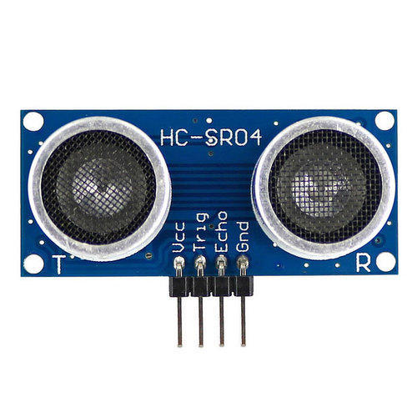

Fig 4 Ultrasonic Sensor along the track

**1.5 Summary:**

It is a way of finding an obstacle and alarming the system using IOT. The railway driver is

alarmed to avoid potential accidents by a methodology which uses a sensor that measures distance that is the ultrasonic sensor that finds the obstacle range and Arduino reads it to alarm. By utilizing a mixture of multiple recognition modules to increase obstacle recognition efficiency and rail detection in every type of weather shows the utilization of an image processing methodology. The method being used is acceptable as different parameters are working well under the normal conditions using the data obtained.

4

**CHAPTER 2**

**LITERATURE SURVEY**

* 1. **Literature Review:**

**2.1.1 General:**

The formal literature survey’s results are presented for our project in this chapter. In the field of image processing and image colorization, there are technological methodologies and processes which we identify. Our final model has some key features due to the help of this survey.

**2.1.2** **Literature Review:**

This term refers to a study of an article, a published paper or some other academia. They are always considered as a paraphrasing work and not the original content. In each of our reference papers, we describe the methodologies, unique features and differences in them.

**2.1.3 Literature Review On Obstacle Detection:**

**[1]** **Alberto Broggi, Pietro Cerri, Pier Claudio Antonello, “Multi-Resolution Vehicle Detection using Artificial Vision”:** This paper was published in IEEE Intelligent Vehicle Symposium. Using a single camera, this paper describes a vehicle detection system. The project is founded on the use of Multi-Resolution images in-order to detect the vehicle. It uses the high symmetry and the low symmetry of the object in order to achieve the current obstacle detection. Then the algorithm detects the various types of the obstacle in the box which is

usually displayed by the CV. All the results which were earlier discovered are now mixed together and the overlapping boundaries are localized to remove the false object detection.

5

**[2] A. K. Shrivastava, A. Verma, and S. P. Singh ,” Distance Measurement of an Object or Obstacle by Ultrasound Sensors using P89C51RD2”:** This paper was published in IJCTE. It measured the distance of the object or we can say obstacle which can be anything moving, stationary, etc. The distance was measured by the ultrasonic sensor which the cheapest and more reliable. This paper usually describes the transfer of the information of the data from transmitter to receiver.

**[3] J. David and N. Cheeke, “Fundamentals of ultrasonic waves,”:** This paper was published in IEEE. This paper usually describes the fundamentals of ultrasonic waves, about their properties and various other things. The Ultrasonic Sensor which usually emits the waves in 180* and the waves are usually meant to detect anything that comes in their path.

**[4] M. Bertozzi, L. Bombini, P. Cerri, P. Medici, P. C. Antonello, M. Miglietta, “Obstacle Detection and Classification fusing Radar and Vision,”:** This paper was published in IEEE Intelligent Vehicles Symposium. This paper usually detects and classify the obstacle on the road in order to avoid major accidents. This is usually done by combing the data coming from the different sensors and the classification of the object is usually done by the three types of the camera in order to remove the false information and to generate true warning in this context.

**[5] Ruder, M.; Mohler, N.; Ahmed, F.; “An obstacle detection system for automated trains,”:**

This paper was published in Intelligent Vehicles Symposium. The paper describes the use of the novel technology such as fusion radar and image sensor in order to detect the obstacle on the tracks. In this paper a high-end sensor which is mounted on the train detects any kind of an obstacle either stationary or moving hundreds of meters before and tells the driver to slower the train by generation of an alert.

6

**2.2 Summary:**

In the following Table 2.1, we group the main approaches for image colorization in the reference

papers and describe important features of each approach.

|  |  |  |
| --- | --- | --- |
| PAPER NAME | AUTHORS | TECHNOLGY USED |
| Multi-Resolution Vehicle Detection using Artificial Vision | Alberto Broggi, Pietro Cerri, Pier Claudio Antonello | AI, Sensors, Distance algorithm |
| Distance Measurement of an Object or Obstacle by Ultrasound Sensors using P89C51RD2 | A. K. Shrivastava, A. Verma, and S. P. Singh | AI, Sensors, Distance algorithm |
| Fundamentals of ultrasonic waves | J. David and N. Cheeke, | AI, Sensors, Distance algorithm |
| Obstacle Detection And Collision Avoidance Using Ultrasonic Distance | Nils Gageik, Thilo Müller, Sergio Montenegro | AI, Sensors, Distance algorithm |
| An obstacle detection system for automated trains | Ruder, M.; Mohler, N.; Ahmed, F | AI, Sensors, Distance algorithm |
| A Practical Obstacle Detection And Avoidance System | Sumit Badal, Srinivas Ravela, Bruce Draper, Allen Hanson, | AI, Sensors, Distance algorithm |

Table 2.1: Summary of Literature Survey

7

**CHAPTER 3**

**SYSTEM ANALYSIS**

* 1. **Existing System:**

The main purpose of the object is to implement an anti-accident or we can say obstruction detection which can prevent disaster. This sensors while be mounted on the train for the data processing.

Graphical user based navigation as suggested by Fernando Garcia. Sometimes processing of data can take time which result in damage due to this sensors will be implemented will proper installation such that the object can be detected out and will not cause any danger to fauna or train in-bound.

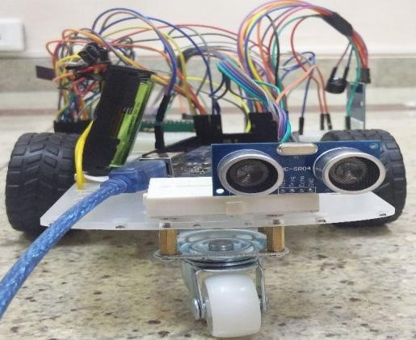

Fig. 5 existing system

8

Fernando Garcia. Sometimes processing of data can take time which result in damage due to this sensors will be implemented will proper installation such that the object can be detected out and will not cause any danger to fauna or train in-bound.

As provided by Jing Ren on November 2018.As the advancement in technology we can basically implement many techniques which can be cheapest and yet challenging approach in order to get a greater outcome. After the data is processed in Arduino system using software, it basically compares length of various obstacle, deletion of background, and shadow removal and some basic classification in order to generate an alert. Mems sensor is basically implemented for the faults in railway tracks.

Convolutional neural networks are highly suitable for processing visual data due to their implicit structure and characteristics. One of the most popular implementations of CNNs for image processing is the VGG16 (Figure 1) by (Zhang, 2016a) . The VGG16 is used for object classification and its architecture and weights used are freely avail- able for general use in their website. It is a collection of 14 million images without copyrights for research and academic use. The VGG16 network (Figure 3.1) contains 16 layers that are designed to manipulate and retain information from the training images in order to detect macroscopic objects and subjects.

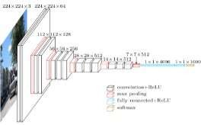Fig 6 Macro-architecture of the VGG16 Network

At this point, we start to analyze the work done by Zhang et al 3 in their ECCV 2016

9

submission (Zhang et al., 2016). They have used a custom architecture which is known as AlexNet and achieved positive results in their so called Aa IJcolorization Turing TestaA I in which human participants are asked to differentiate between a real image and an artificially colorized one. Zhang et al have managed to solve the object color redundancy problem sufficiently, the fundamental fact that an object may have multiple plausible colorizations. For achieving this, they have incorporated a unique loss metric which is re-weighted during training time instead of being static. This allows their model to use the entire information in the training dataset instead of converging on a few highly contributing images. Finally, they have taken the annealed mean of the distribution to produce the final colorization. Here, the parameter T, closely relates to the color temperature in the output image, that is, lowering T tends to produce images with more reddish and yellowish hues and increasing T produces images with pronounced blues and greens. By trial and error, they have chosen the T-value 0.38, which gives satisfactory results even though it is on the warmer end of the color spectrum. This may be due to the overall color temperature of the dataset being on the slightly warmer side.

Use of feature extractors: In (Baldassarre et al., 2017), they have used a pre-trained feature extractor to validate color information generated by their primary CNN. They achieve this by using a system of dual-channel decoders and encoders. The source grayscale image which initially only contains the Luminance (L) channel is down- sampled to a computation friendly 224x224 dimension. One copy of this down-sampled image is fed to the pre-trained feature extractor InceptionResNet, which produces a vector containing the coherent information about the image. This information is then ’fused’ with the output of the encoder in the primary system, which convolutes a down- sampled image through 8 layers. The fusion causes the primary system to recognize features that are not immediately apparent from the L channel of the image alone. The fused result is then fed to the decoder, which is essentially a reverse convolution network, designed to amplify certain features in images. The results from the decoder are up-sampled to produce the colored version of the

10

grayscale image. Each of the module in the system has a ReLU activation function, which is just a Linear Unit function, except for the last layer, which is hyperbolically tangential. The work by Baldassare et al generates images with high accuracy and photorealism. However, due to the relatively low volume of the dataset used (about 60,000 out of the 14 million images in ImageNet), it performs better when some features are present in the image.

By reviewing and studying reference papers related to image processing and colorization, we have gathered vital information regarding colorization processes and techniques. We have learned about the strengths and weaknesses of each technique and described 2 of the techniques in detail. Here are some of our observations from the reference papers:

* The L x *α* x *β* color space is objectively better for training colorization systems due to the localized nature of information in L*αβ* channel images.
* Using a pre-trained feature extraction model or an object classification model as a secondary source of information from the source image can cut down on training time and resources required considerably.
* Down-sampling of the source images to a standardized small size is essential to reduce computational complexity, even if it reduces the amount of detail that can be produced in the final images.
* Up-sampling or decoding of the encoded channel images leads to unwanted noise and artifacts in the output images that reduce visual appeal.

11

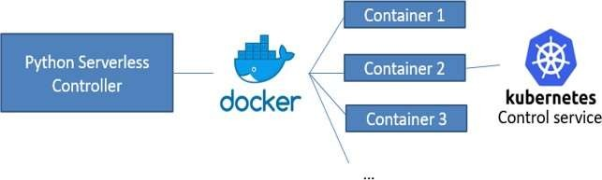

Fig 7 Old Training Architecture

We propose several improvements that can be made to increase the accuracy or col- orization plausibility of the models described above. In the first model by (Zhang et al., 2016), the training set was vast, but the impact of each individual image was negligible, thus the overall accuracy of the system could theoretically be increased by weighting the input training images by their relevance or by using a separate feature-weight dis- tributor as show in Figure 3.3. This can lead to more accurate colourization in abstract objects with no context. Their choice of T-value and learning rate is optimal and the only other improvements in their models can be made by replacing the architecture with a more complex one, similar to (Segalos, 2014). However, the addition of dimensions in the model leads to reduction in information distribution within the model and re- quires careful optimization and tweaking to perfect. We realized that, for colorizing each image, we had to contact the remote cloud server which contained the model. This causes a huge overhead to the system. Therefore we have moved the model to our client machine, reducing processing time by trading color reproduction accuracy.

12

* 1. **Proposed System:**

Proposed system is usually designed by mounting ultrasonic sensors with a range from 0 to 180° on the railway track.

Then, the processed data is being sent to Arduino software and an alert is being generated. When an object is being detected by the sensors in the range, an alarm is being generated to the driver of the train in order to avert a major accidents.

ZigBee TX, RX is currently used in order to send and receive the processed data to main

system. Mems sensor will be implemented on the railway in order to identify uneven angular deflections on the track. Along with this, we will also implement eye blink sensor which will alert the driver if the driver fall asleep in order to divert major accident.

ZigBee TX, RX is currently used in order to send and receive the processed data to main

system. Mems sensor will be implemented on the railway in order to identify uneven angular deflections on the track. Along with this, we will also implement eye blink sensor which will alert the driver if the driver fall asleep in order to divert major accident.

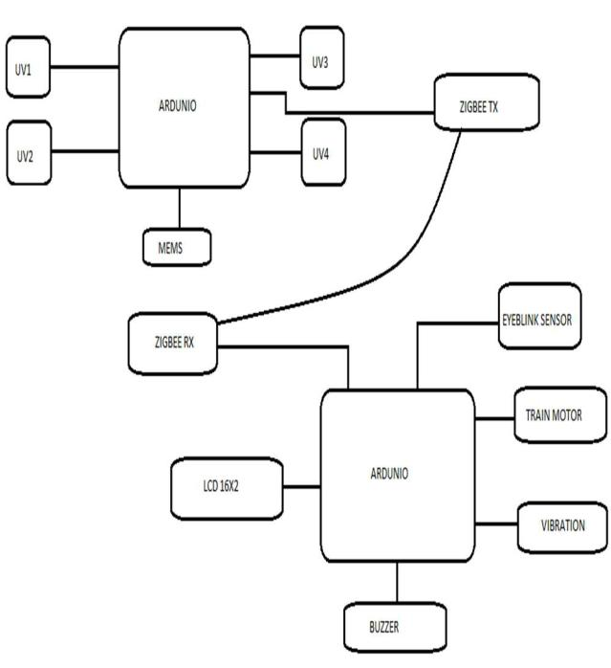

Fig. 8 Proposed project

13

* 1. **Advantages of Proposed System:**

Our proposed system will reduce training time exponentially without a noticable accuracy loss. This will reduce the resources and expenses utilized by the system.

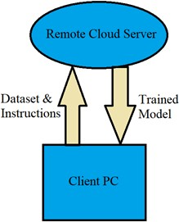

Fig 9 proposed framework

At the same time, it will also increase the number of colorizations done in a particular time frame making it a much more viable colorization option when compared to its prede-cessor models.

* 1. **Summary:**

It is a way of finding an obstacle and alarming the system using IOT. The railway driver is alarmed to avoid potential accidents by a methodology which uses a sensor that measures distance that is the ultrasonic sensor that finds the obstacle range and Arduino reads it to alarm.

By utilizing a mixture of multiple recognition modules to increase obstacle recognition efficiency and rail detection in every type of weather shows the utilization of an image

processing methodology. The method being used is acceptable as different parameters are working well under the normal conditions using the data obtained.

14

**CHAPTER 4**

#### **SYSTEM DESIGN**

#### **System Architecture:**

Proposed method is usually designed by mounting ultrasonic sensors with a range from 0 to 180° on the railway track. Then, the processed data is being sent to Arduino software and an alert is being generated.

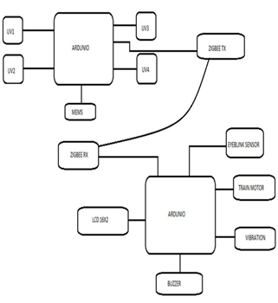

Fig 10 System Architecture

When an object is being detected by the sensors in the range, an alarm is being generated to the driver of the train in order to avert a major accidents. ZigBee TX, RX is currently used to

transmit and receive the processed information to main system.

15

* 1. **Transmission:**

ZigBee connection is used for wireless personal area, being the result from ZigBee alliance. They are used for sensors related networks and for controlling. It is part of the IEEE 802.15.4 standard. The standard works with physical and Media Access Control (MAC) layers and is used to deal with devices at low-data rates. The data rate of 250 kbps between sensors and controllers is most suited for cyclic and middle two way transmission of data. It is popularly used for dominating and watching applications spreading 10-100 meters within the range and is a cheap and less power mesh network. Compared to other short-range.

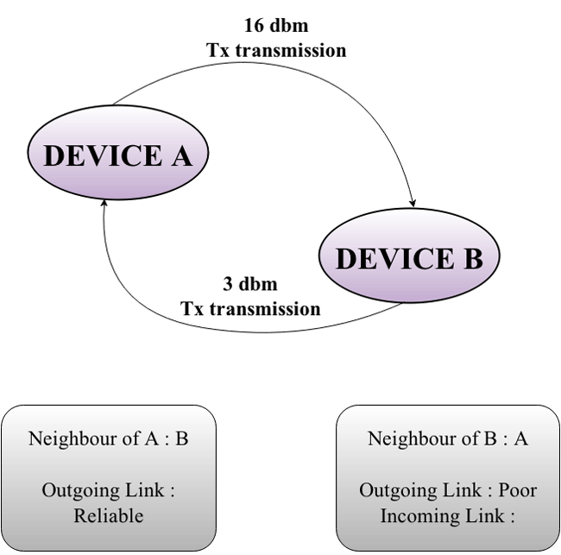

Fig 11 Transmission

wireless sensor communication system such as Bluetooth and Wi-Fi, it is a communication system more cheaper and uncomplicated. Various types of network designs can use ZigBee. These designs could be master to master or master to slave.

The battery power is saved as it could be utilized in various modes. The networks of Zigbee allow numerous nodes to be connected together and are extensible with the routers for producing a wider area network.

16

* 1. **UML Diagram:**

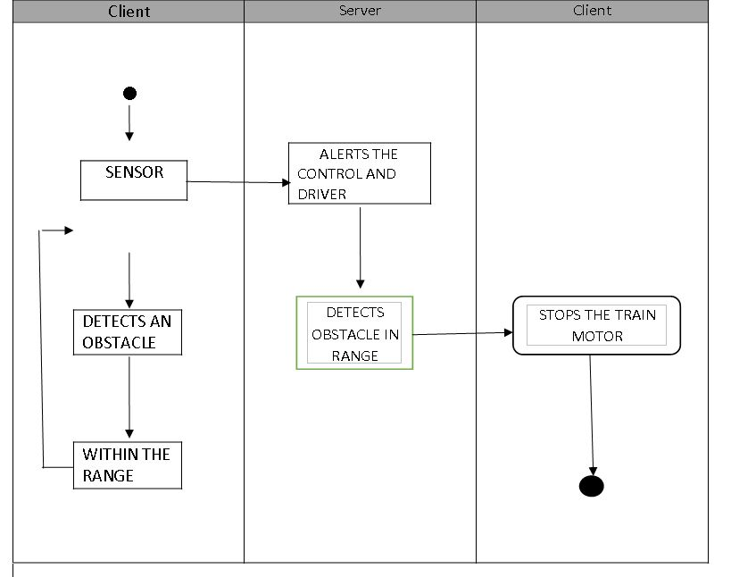

17

**4.4 Star Diagram:**

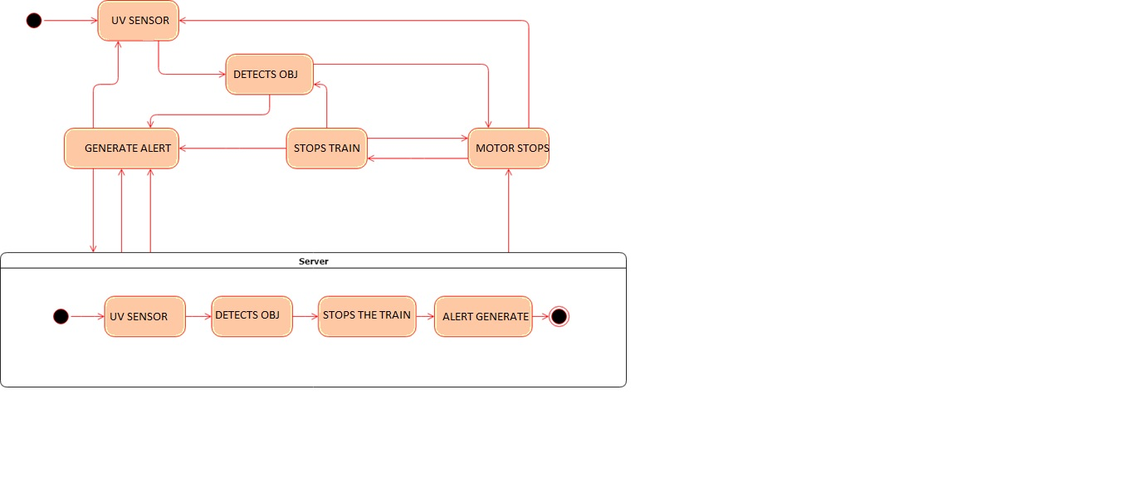

**4.5 Summary:**

It is a way of finding an obstacle and alarming the system using IOT. The railway driver is

alarmed to avoid potential accidents by a methodology which uses a sensor that measures distance that is the ultrasonic sensor that finds the obstacle range and Arduino reads it to alarm. By utilizing a mixture of multiple recognition modules to increase obstacle recognition efficiency and rail detection in every type of weather shows the utilization of an image processing methodology. The method being used is acceptable as different parameters are working well under the normal conditions using the data obtained.

18

#### **CHAPTER 5**

**SYSTEM REQUIREMENTS AND SPECIFICATIONS**

**5.1 Hardware Requirements:**

**5.1.1 Control Room Requirement:**

Any normal home PC (laptop or desktop) will suffice as a client as long as it can compile and run python files and has a relatively decent internet connection. i.e. The minimum requirements are:

* 4GB RAM
* 20GB HDD space (mainly to store the data set)
* Mbps internet connection

**5.1.2 Server Requirement:**

The cloud service we have used is digital ocean. Digital Ocean is economically more reasonable when compared to Amazon Web Services or Microsoft Azure. Our earliest training architecture stored the data set on the server which increased the overhead exponentially. Now, we store the data set on our client and send the Red Green Blue (RGB) matrix to the server which reduces overhead and increases efficiency with a negligible accuracy trade-off.

So now the server PC requires:

* 10GB of HDD to store the model, input and output matrix

* Preferably distributed multiprocessor system with high core and thread count

19

* GPU with high CUDA core count if using Graphical Processing Unit (GPU) mode
* atleast 16GB of RAM

**5.2 Software Requirement:**

#### **5.2.1 Tensor Flow:**

#### It is a library of machine learning which is open-source that is used by developers and enterprises for the ML and deep learning needs. Tensorflow is a big package to install and easily exceeds 500MB with all the plugins and mappers. Tensorflow provides the easy to use high level Caffe and Keras APIs for easing machine learning model creation and training. Tensorflow can be run on the CPU as well as the GPU, which can really speed up machine learning tasks (Ranier, 2016).

#### 

#### Fig 12 Tensorflow

#### 20

#### **5.2.2 Arduino Software:**

#### Arduino manufactures single-board microcontrollers and microcontroller kits and is an open- source software and hardware company, user and project community for building digital devices. For permitting the manufacture of software distribution and Arduino boards by anyone, its products are licensed under the GNU General Public License (GPL) or the GNU Lesser General Public License (GPL). Commercially these Arduino boards are available as do-it-yourself (DIY) kits or in preassembled form.

#### 

#### Fig 13 Arduino

#### **5.2.3 Apache Tomcat:**

#### Apache Tomcat is a popular web server and a client facing reverse proxy which is open source and developed by the Apache Software Foundation. Tomcat generally only allows Java

#### applications to be directly hosted on it. We have used an open-source fork of the Tomcat server which comes installed with the mod_wsgi package, that allows WSGI applications to be hosted directly. Then, we packaged our Python web application as a standalone WSGI container and deployed locally for access on the network.

#### 

#### 21

#### This way, clients requesting images to be colorized can do so over HTTP and HTTPS.

#### 

#### Fig 14 Apache Tomcat

#### **5.2.4 Linux:**

Linux is an openly available operating system that is used by servers worldwide. It is open-source and developed by people around the world. It was invented by Linus Tor- valds for open source computing. It inherited heavily from the Unix family of operating systems. It is suggested here to use Linux instead of Windows because of the dependencies of our project. The package caffe, pypy do not compile on Windows without disabling compiler signature verification, and due to the absence of C-level libraries such as zlib and openssl.

#### **5.3 Summary:**

It is a way of finding an obstacle and alarming the system using IOT. The railway driver is alarmed to avoid potential accidents by a methodology which uses a sensor that measures distance that is the ultrasonic sensor that finds the obstacle range and Arduino reads it to alarm.

22

By utilizing a mixture of multiple recognition modules to increase obstacle recognition efficiency and rail detection in every type of weather shows the utilization of an image processing methodology. The method being used is acceptable as different parameters are working well under the normal conditions using the data obtained.

#### 23

#### **CHAPTER 6**

#### **SYSTEM IMPLEMENTATION**

#### **6.1 ULTRASONIC SENSOR:**

#### Ultrasonic sensors are implemented because they utilizes electrical plus mechanical energy in order to measure the target object distance from the sensor. Ultrasonic waves are commonly termed as the longitudinal waves that are a series of compacting and distillation of wave diffused through the medium.

#### 

#### Fig 15 Ultrasonic sensor

#### When these UV waves are projected on to any material an outcome of these projected reflection occurs over a wide solid angle which may be as high as 180°. Due to this certain waves are

#### projected back to transducer as reflected sounds. This will help in detection of the object and making the driver aware. Here we can define distance (L) between the object and (v) can be

#### defined as the speed of ultrasonic waves.

#### 24

#### 

Fig 16 Working of Ultrasonic sensor

Where‘t’ is the time taken by the wave to reach back to the sensor and theta is the angle between the horizontal and the path taken as shown in the figure. If the object is in motion, instruments based on Doppler shift are used.

UV sensors are used for determining exposure to ultraviolet radiation in laboratory or environmental settings. They are transmitters that respond to one type of energy signal by producing energy signals of a different type. Generally, these output signals are electrical signals that are routed directly to an electrical meter for observation and recording. The generated electrical signals from UV sensors can also be sent to an analog-to-digital converter (ADC), and then to a computer with software for generating graphs and reports.

There are many types of UV sensors. Examples include:

* UV phototubes
* light sensors
* UV spectrum sensor

25

#### **6.2 Mems Sensor:**

#### These sensors consists of computers that have little mechanical devices embedded on semiconductor chips. These devices could be valves, gears or mirrors. There is a fixed part and a moving part in a MEMS based vibration sensor. They help in conversion of mechanical waves produced by the railway track to an electrical signal.

#### 

#### Fig 17 Mems Sensor

#### 

#### To enhance the response of electrical signal, the device has elements which are piezoresistive or piezoelectric. There is an electrode inside the plate of capacitor and the movable element is connected to the rigid element. The vibration travels through the rigid element

The accelerometer can be linked to the data acquisition card in the computer and is used to collect data. The installation time is reduced to 36 seconds per sensor as sensors could be simply stuck on objects quickly as no multi-point alignment is needed. When eddy currents are created in the material by a magnet which is generally an electromagnet that produces a varying frequency field, another magnetic field is produced in the material by the eddy currents which can be sensed by the magnetometer.

The magnetic field produced from eddy current displays an invariable pattern as it goes along the object being checked if there is no defect or crack in the pipeline.

26

The magnetic field is varied and the eddy current is disrupted if there is a gap in the object, permitting a sensitive magnetometer to detect the flaw.

There are two u-shaped micro beams that are clamp free in the structure, which are attached to the substrate of silicon. There are two active and passive piezo resistors (active are present on the micro beams while the passive are on the substrate) on the Wheatstone bridge which the sensor uses for piezo resistive sensing.

A longitudinal strain (εx) is generated by the Lorentz force modifying the resistance values on the two active piezo resistors given by: ΔR=GεxR. The ΔR is resistance fluctuation of variable piezo resistors, R is the resistance and G is piezo resistor gauge factor. An output voltage shift (Vout) is produced in the Wheatstone bridge by the alteration in the active piezoresistors resistance.

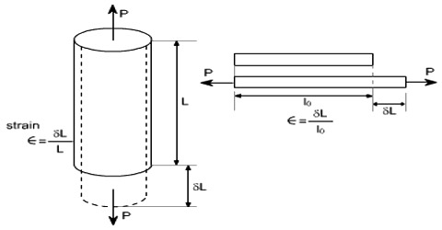

Fig 18 Longitutional Strain

Vout is calculated for this case, by: Vout = (ΔR/2R+ΔR)*Vbias. Vbias is present in Wheatstone bridge and is the bias voltage.

The proportion of the fluctuation of the output voltage to the range of external magnetic field (ΔBx) is used to derive the sensor sensitiveness(S):S=ΔVout /ΔBx Also, the output voltage in the wheatstone bridge is used to calculate the order of the external magnetic field.

27

Among the presently available uses of MEMS or those under study are:

1. They are used for constant tracking and can also sense parcel treatment en route when included in courier parcels as global position system sensors

2. It can sense and react to air flow by changing the wing surface resistance with the sensors built into the fabric of an airplane wing, effectively creating a myriad of tiny wing flaps

3. At 20 nanosecond switching speeds, they can switch light signals over different paths acting as optical switching devices

4. They improve energy savings dramatically by acting as sensor-driven heating and cooling systems

5. Based on atmospheric stress sensing, they can alter the flexibility properties of material building supports with embedded sensors

The advantages of MEMS sensor include the following:

* Consistency is essential to devices based on MEMS and the manufacturing of MEMS is semiconductor IC manufacturing like low-cost mass invention
* The MEMS device size will determine 20 micro-meter to a millimeter range and the size of sensor sub-components will be within 1 to 100 micrometers range as well
* Very low power consumption
* Simple to change or to incorporate into systems

28

* Small thermal constant
* Shock, vibration and radiation can be highly opposed by it
* The tolerance of thermal development is better
* Parallelism

**6.3 ZIGBEE:**

ZigBee connection is used for wireless personal area, being the result from ZigBee alliance. They are used for sensors related networks and for controlling. It is part of the IEEE 802.15.4

standard. It works with Media Access Control (MAC) layer and physical layer and can deal with devices at low-data rates. The data rate of 250 kbps between sensors and controllers is most suited for cyclic and middle two way transmission of data. It is popularly used for dominating and watching applications spreading 10-100 meters within the range and is a cheap and less power mesh network. Compared to other short-range.

Wireless sensor communication system such as Bluetooth and Wi-Fi, it is a communication system more cheaper and uncomplicated. Various types of network designs can use ZigBee.

These designs could be master to master or master to slave.

The battery power is saved as it could be utilized in various modes. The networks of Zigbee allow numerous nodes to be connected together and are extensible with the routers for producing a wider area network.

There should be at least one coordinator that will be the root and will be the bridge of the network in all Zigbee networks.

29

While carrying out the receiving and transmission of data, the coordinator will be accountable for controlling and keeping content.

The information is passed to and fro from Zigbee routers to other components and are the intermediate components that allow this.

The battery power will be saved as the end devices will have a small amount of function to interact with parent nodes in a way which saves it.

Depending on the various types of networks like tree, mesh and star networks, the number of coordinates, end devices and routers will depend.

The Institute of Electrical and Electronics Engineers (IEEE) in 2003 gave the ratification to the 802.15.4 specification upon which the Zigbee stack operates. It (specification) is intended for battery-operated and low-cost devices and is a packet-based radio protocol.

Due to this protocol, the battery life of devices can last for several years and the devices can communicate in a variety of network topologies.

The member companies of the Zigbee Alliance have created and ratified the Zigbee protocol. The Zigbee Alliance membership comprise of over 300 leading technology firms, service companies, OEMs and semiconductor manufacturers. Secure, reliable wireless network architectures are characterized by the Zigbee protocol designed to provide an easy-to-use wireless data solution.

Through hostile RF environments that are common in industrial and commercial applications, the Zigbee protocol is designed to communicate data through this.

When the information and communication of the devices are less, the Zigbee technology provides a stable, high efficient networking using low data transfer rates.

Using the Zigbee gateways, Zigbee devices are integrated into the systems across IOT

(Internet of things) industry establishing a wireless communication.

30

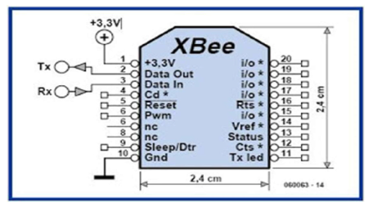

Fig 19. Zigbee Mechanism

Features of Zigbee protocol include:

1. Multiple network topologies like point-to-multipoint, point-to-point and mesh networks are supported

2. Battery life provided is long due to low duty cycle

3. Latency is low

4. (DSSS) Direct Sequence Spread Spectrum

5. It can support around 65,000 nodes per network

6. For secure data connections, it provides a 128-bit AES encryption

7. Retries, acknowledgments and collision avoidance

The following two main sections are present in the Zigbee architecture (Zigbee Stack):

* Foundation Layers

31

* Application and Interface Section

The IEEE 802.15.4 standard defines the Foundation Layer. The foundation layers for this technology are both Physical layer and Medium Access Control (MAC) layers. The physical layer defines the electrical and physical characteristics. The interface between the physical and network layers is provided by the Medium Access Control (MAC) layer.

The Network Layer and Application Layer is contained by the Zigbee Specifications and it defines the Interface and Application section.

The MAC layer and the application layer have an interface between them provided by the Network layer. The different network topologies like star, tree and mesh topologies are established and routed by this layer. The responsibilities of the network layer include assigning node addresses, initiation of a network, configuring of new devices and providing secured transmission.

There are sub layers that are present in the Application layer namely the Application

Framework and the Application Support Sub Layer.

In a network that supports automatic retries, it is common to filter the packets for end devices, checks for duplicity of packets done by the Application Support Sub Layer

(APS).

How the data confirmation is executed, how data requests and how end points are implemented for that particular vendor is represented by the Application Framework.

**6.4 BUZZER:**

A buzzer also called as a beeper is a signaling device (audio), which could be mechanical, electromechanical or piezoelectric. It is a small loudspeaker that you could link directly to an

Arduino (piezo buffer). When you apply electricity on the crystals they change their form which is a consequence of piezoelectricity.

32

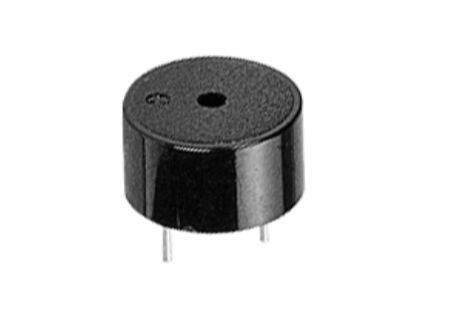

Fig 20. Buzzer

The crystals will produce a sound when providing an electric signal at the correct frequency. If there is a sticker on top of the buzzer, remove it. Link a pin to the digital pin 8 and the other end to the Arduino’s ground. By utilizing tone, you could provide sounds from a buzzer using the Arduino. By telling in which pin the buzzer is present, how long in milliseconds and the frequency you require for the buzzer to keep producing the tone, you can interact with it.

In 1831 the electric buzzer was invented by Joseph Henry. They were phased out in favor of musical chimes in the early 1930s which had a softer tone and were used in early doorbells.

The Japanese manufacturers had invented the piezoelectric buzzers or piezo buzzers and they fitted into a wide variety of products during the 1970s to 1980s. Due to cooperative efforts by Japanese manufacturing companies, this advancement mainly came about. To bring about several piezoelectric innovations and inventions, they established the Barium Titanate Application Research Committee in 1951 allowing the companies to be competitively cooperative.

33

**6.5 LCD:**

LCD refers to Liquid crystal displays (LCDs). The components of LCD have the properties of liquids and crystals both. They have a range of temperatures in which the molecules are joined together in a sequential form just like crystals and have similar mobility as they would have in a liquid, they do not have a melting point.

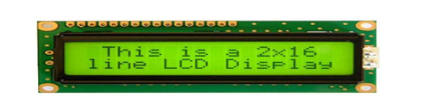

Fig 21. LCD 16*2

The molecules are aligned in a particular direction, when sufficient voltage is added to the electrodes. The desired components are highlighted or activated when the polarizers would rotate the light rays from the LCD.

The liquid crystal material is sandwiched in between the two glass panels of the LCD.

Transparent electrodes are coated on the inner surface of the glass plates which define the symbols, patterns or character to be displayed. The liquid crystal molecules maintain a defined orientation angle which happens because the polymeric layers are present in between the electrodes and the liquid crystal.

The two glass panels are pasted on each polarizer. The light rays passing through them would rotate by these polarizers to a definite angle in a particular direction.

The light rays are rotated by the liquid crystal and the two polarizers when the LCD is in the off state, from the LCD the light rays come out without any orientation and hence the LCD appears transparent.

34

The liquid crystal molecules would be aligned in a specific direction when sufficient voltage is applied to the electrodes. The result will be the activating or highlighting of the desired characters when the light rays passing through the LCD would be rotated by the polarizers.

With only a few millimeters thickness, the LCD’s are quite lightweight. The LCD’s are compatible with low power electronic circuits since the LCD’s consume less power and can be powered for long durations.

Light is needed to read the display since LCD’s don’t generate light. Reading is possible in the dark by using backlighting. They have a wide operating temperature range and a long life.

The LCD’s are more customer friendly as changing their display size or their layout size is relatively simple.

The simple seven-segment displays having a limited amount of numeric data are the

LCD’s used exclusively in watches, calculators and measuring instruments. A wider temperature range, better legibility and more information displaying capability have resulted due to the recent advances in technology. In telecommunications and entertainment electronics, the LCD’s are being extensively used as a result of the advancements. The cathode ray tubes (CRTs) used for the display of text and graphics and small TV applications having started getting replaced by the LCDs.

**6.6 Eye Blink Sensor:**

IR is supported on the Eye Blink sensor. As per the eye blink the change in the eye will alter. If the eye is closed, the output is high and if it is open, it is low. We can understand if the eye is open or close by this. To interact with the alarm the logic circuit is provided with the output.

35

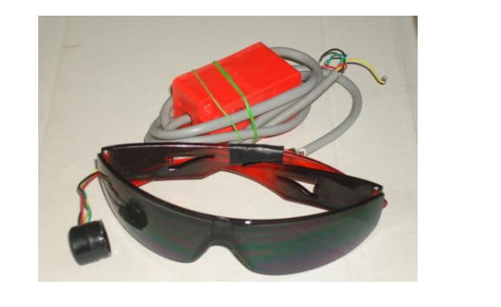

Fig 22. Eye Blink Sensor

Using a phototransistor and differentiator circuit, the eye-blink sensor monitors the changes in the reflected light and works by illuminating the eye and eyelid area with infrared light. The positioning and aiming of the detector and the emitter with respect to the eye decides the exact functionality greatly.

The features are:

1. LED indicating the EYE BLINK

2. For directly connecting to microcontroller, instant output digital signal

3. The size is compact

4. +5V DC is the working voltage

36

**6.7 Summary:**

It is a way of finding an obstacle and alarming the system using IOT. The railway driver is alarmed to avoid potential accidents by a methodology which uses a sensor that measures distance that is the ultrasonic sensor that finds the obstacle range and Arduino reads it to alarm.

By utilizing a mixture of multiple recognition modules to increase obstacle recognition efficiency and rail detection in every type of weather shows the utilization of an image processing methodology. The method being used is acceptable as different parameters are working well under the normal conditions using the data obtained.

37

#### **CHAPTER 6**

#### **CONCLUSION AND FUTURE ENHANCEMENTS**

**7.1 Conclusion:**

It is a way of finding an obstacle and alarming the system using IOT. The railway driver is alarmed to avoid potential accidents by a methodology which uses a sensor that measures distance that is the ultrasonic sensor that finds the obstacle range and Arduino reads it to alarm.

By utilizing a mixture of multiple recognition modules to increase obstacle recognition efficiency and rail detection in every type of weather shows the utilization of an image processing methodology. The method being used is acceptable as different parameters are working well under the normal conditions using the data obtained.

**7.2 Future Enhancements:**

By utilizing a mixture of multiple recognition modules to increase obstacle recognition efficiency and rail detection in every type of weather shows the utilization of an image processing methodology.

The method being used is acceptable as different parameters are working well under the normal conditions using the data obtained. It is a way of finding an obstacle and alarming the system using IOT.

The railway driver is alarmed to avoid potential accidents by a methodology which uses a sensor that measures distance that is the ultrasonic sensor that finds the obstacle range and Arduino reads it to alarm.

38

**REFERENCES**

[1] Alberto Broggi, Pietro Cerri, Pier Claudio Antonello, “Multi-Resolution Vehicle Detection using Artificial Vision,” IEEE Intelligent Vehicles Symposium, pp. 310-314.

[2] A. K. Shrivastava, A. Verma, and S. P. Singh,” Distance Measurement of an Object or

Obstacle by Ultrasound Sensors using P89C51RD2”, International Journal of Computer Theory and Engineering, Vol- 2, No-1,pp.

[3] J. David and N. Cheeke, “Fundamentals of ultrasonic waves,” CRC Press, Florida, USA.

ISBN 0-8493- 0130-0.

[4] Nils Gageik, Thilo Müller, Sergio Montenegro, “Obstacle Detection And Collision

Avoidance Using Ultrasonic Distance Sensors For An Autonomous Quadcopter” University of Würzburg, Aerospace Information Technology (Germany) Würzburg.

[5]Ruder, M.; Mohler, N.; Ahmed, F.; “An obstacle detection system for automated trains,”

Intelligent Vehicles Symposium, Proceedings. IEEE., pp. 180-185.

[6] Sumit Badal, Srinivas Ravela, Bruce Draper, Allen Hanson, “A Practical Obstacle Detection And Avoidance System”, Computer Vision Laboratory , University of Massachusetts.

39

**APPENDIX A**

**SCREENSHOT OF THE PROJECT:**

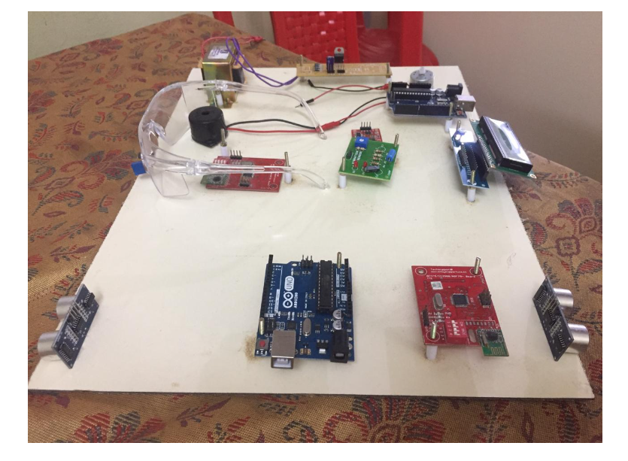

**CODE (TRANSMISSION):**

const int trigPin = 9;

const int echopin= 10;

const int trigPin1 = 11;

const int echopin1= 12;

int t;

int d;

int t1;

long duration;

40

long duration1;

int distance;

void setup() {

pinMode(trigPin, OUTPUT); // Sets the trigPin as an Output

pinMode(echopin, INPUT); // Sets the echoPin as an Input

pinMode(trigPin1, OUTPUT); // Sets the trigPin as an Output

pinMode(echopin1, INPUT); // Sets the echoPin as an Input

Serial.begin(9600); // Starts the serial communication

}

void loop() {

// Clears the trigPin

digitalWrite(trigPin,LOW);

delay(1000);

digitalWrite(trigPin,HIGH);

delay(1000);

digitalWrite(trigPin,LOW);

t=pulseIn(echopin,HIGH);

d=t*0.034/2;

// Prints the distance on the Serial Monitor

//Serial.print(“Distance1: ”);

//Serial.println(d);

digitalWrite(trigPin1,LOW);

delay(1000);

digitalWrite(trigPin1,HIGH);

delay(1000);

digitalWrite(trigPin1,LOW);

t=pulseIn(echopin1,HIGH);

distance=t*0.034/2;

// Prints the distance on the Serial Monitor

//Serial.print(“Distance2: ”);

//Serial.println(distance);

if(d<=10)

41

{

Serial.print(“A”);

delay(1000);

}

if(distance<=10)

{

Serial.print(“B”);

delay(1000);

}

}

**CODE (RECEIVER):**

//#############___________zigbee rx____________################

#include<LiquidCrystal.h>

LiquidCrystal lcd(8, 9, 5, 4, 3, 2); // sets the interfacing pins

Include<SoftwareSerial.h>

char c;

int i=0;

float mems;

int memspin=A0;

void setup()

{

Serial.begin(9600);

lcd.begin(16,2);

pinMode(6, OUTPUT); // Sets the trigPin as an Output

pinMode(13, OUTPUT); // Sets the trigPin as an Output

pinMode(10, INPUT); //eye Blink

pinMode(7, INPUT); // Vibration

pinMode(A0, INPUT); // Vibration

lcd.setCursor(0,0);

42

lcd.print(“DRIVER”);

delay(1000);

//lcd.clear();

}

void loop()

{

if(Serial.available()>0)

{

c=Serial.read();

Serial.print(c);

if (c==’A’)

{

digitalWrite(6,LOW);

digitalWrite(13,HIGH);

delay(2000);

digitalWrite(13,LOW);

lcd.setCursor(0,1);

lcd.print(“UV1 ENGINE1 OFF”);

delay(500);

lcd.clear();

}

if (c==’B’)

{

digitalWrite(6,LOW);

digitalWrite(13,HIGH);

delay(1000);

digitalWrite(13,LOW);

lcd.setCursor(0,1);

lcd.print(“UV2ENGINE1OFF”);

delay(500);

lcd.clear();

43

}

}

digitalWrite(6,HIGH);

if(digitalRead(7)==LOW)

{

digitalWrite(6,LOW);

lcd.setCursor(0,0);

lcd.print(“Vibration ”);

lcd.setCursor(0,1);

lcd.print(“detected”);

delay(2000);

lcd.clear();

digitalWrite(6,HIGH);

}

mems=analogRead(memspin);

lcd.setCursor(0,0);

lcd.print(“Angle ”);

lcd.setCursor(0,1);

lcd.print(mems);

delay(2000);

lcd.clear();

if(mems>500)

{

digitalWrite(6,LOW);

delay(2000);

digitalWrite(6,HIGH);

}

if(digitalRead(10)==LOW )

{

i++;

lcd.setCursor(0,0);

lcd.print(“IR Level ”);

44

lcd.setCursor(0,1);

lcd.print(i);

delay(2000);

lcd.clear();

if(i>5)

{

digitalWrite(6,LOW);

lcd.setCursor(0,0);

lcd.print(“Drowsiness ”);

lcd.setCursor(0,1);

lcd.print(“detect”);

digitalWrite(13,HIGH);

delay(2000);

digitalWrite(13,LOW);

digitalWrite(6,LOW);

lcd.clear();

i=0;

}

}

}

45